1010_CPP Enrollment initiated by EV for an Single customer Electric Meter
Contract No. 4012976394
Material No. 88000104
Serial No. 20003234
Equipment No. 100004736946
Contract Account. 100045173117
Functional Location. 6001186157

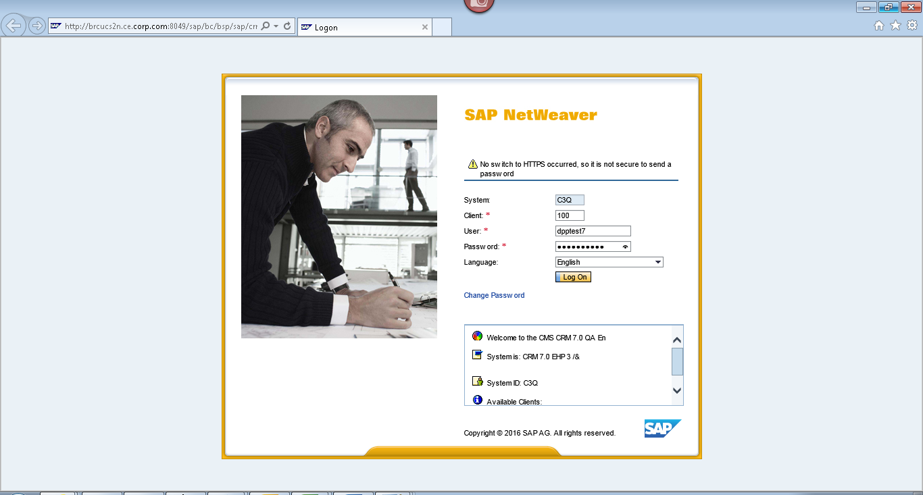
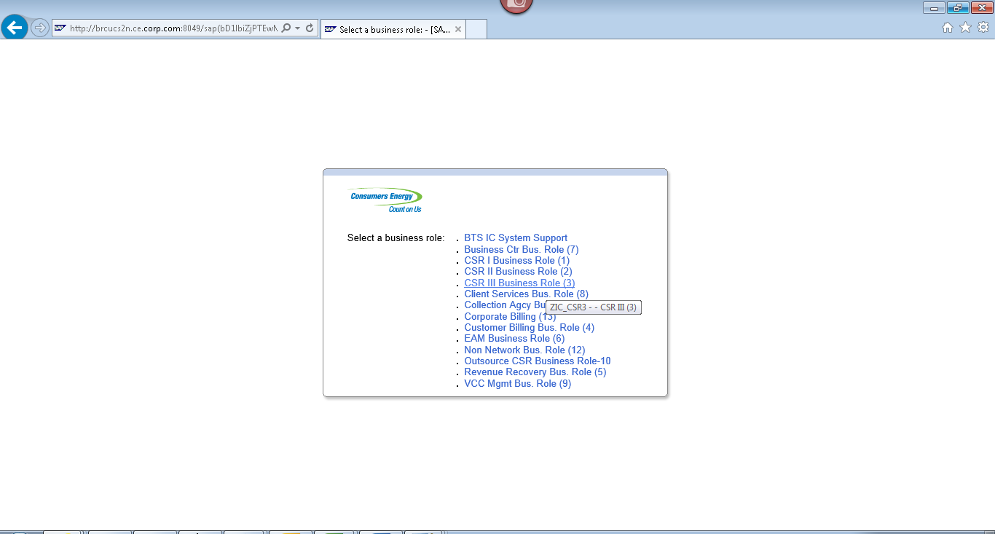
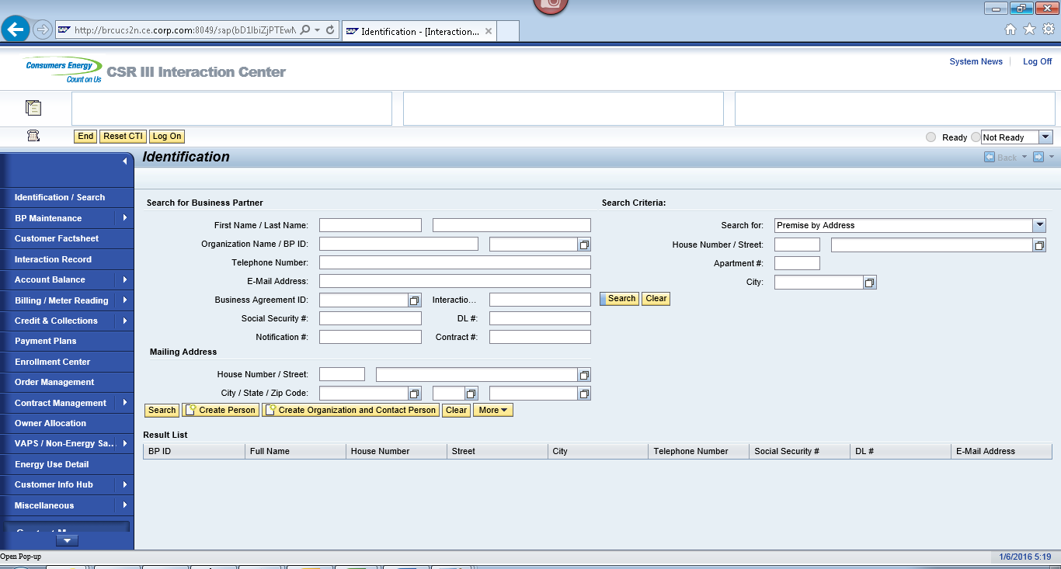
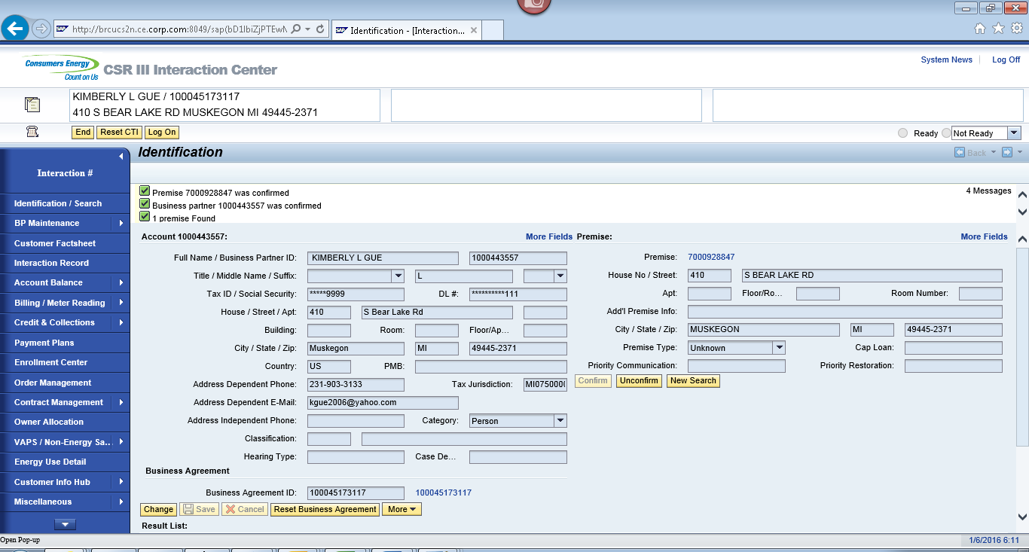
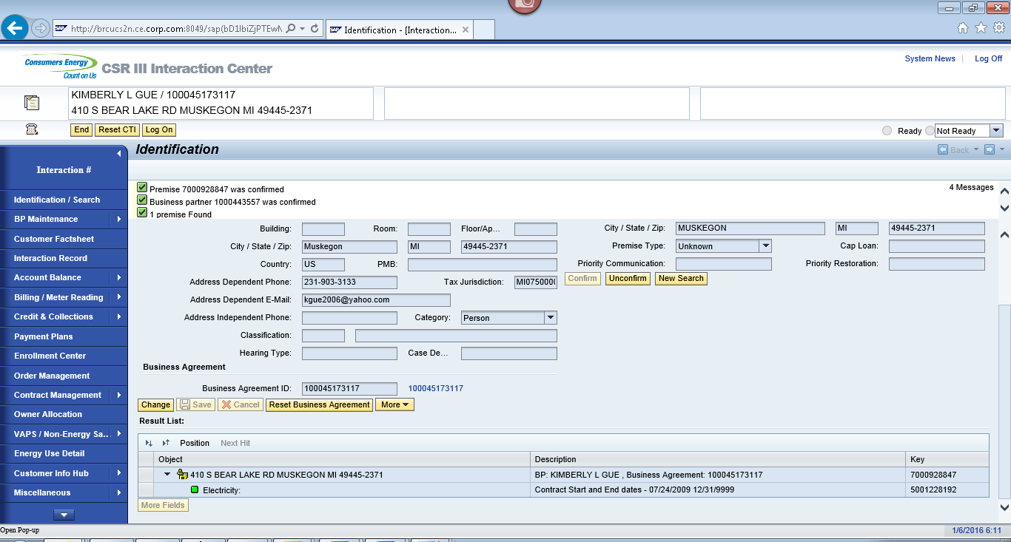
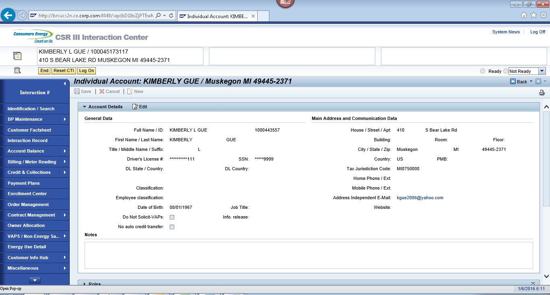
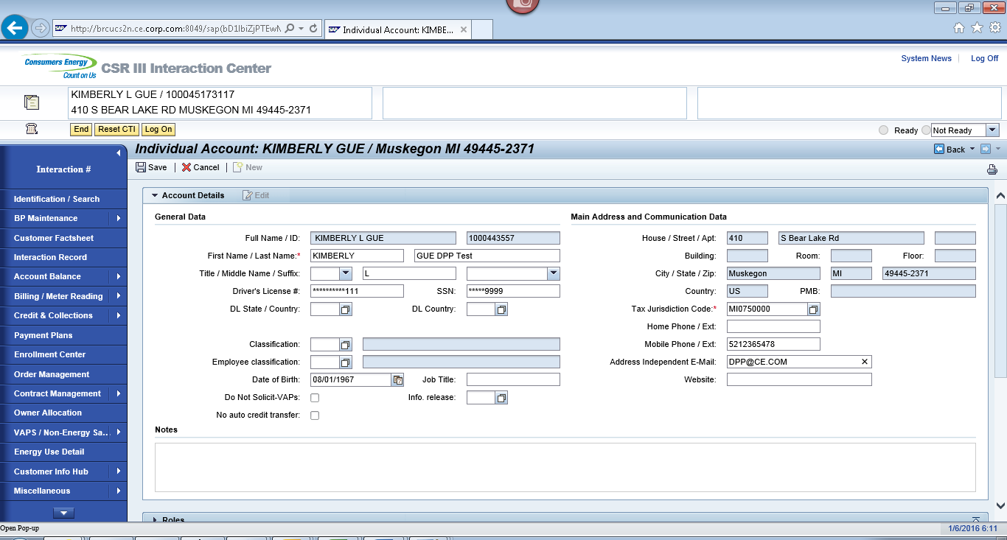
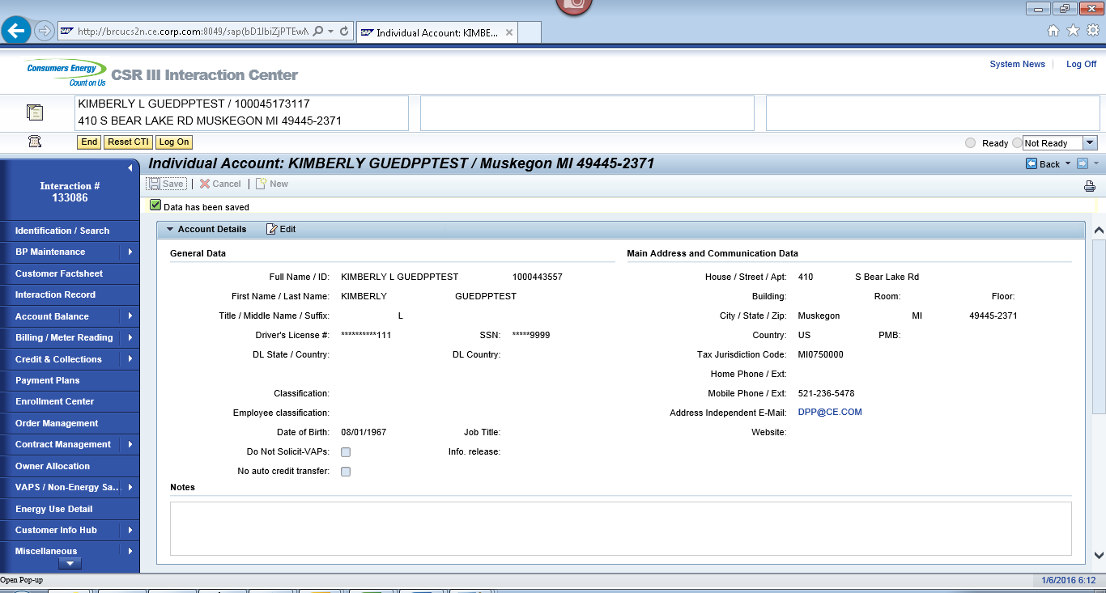

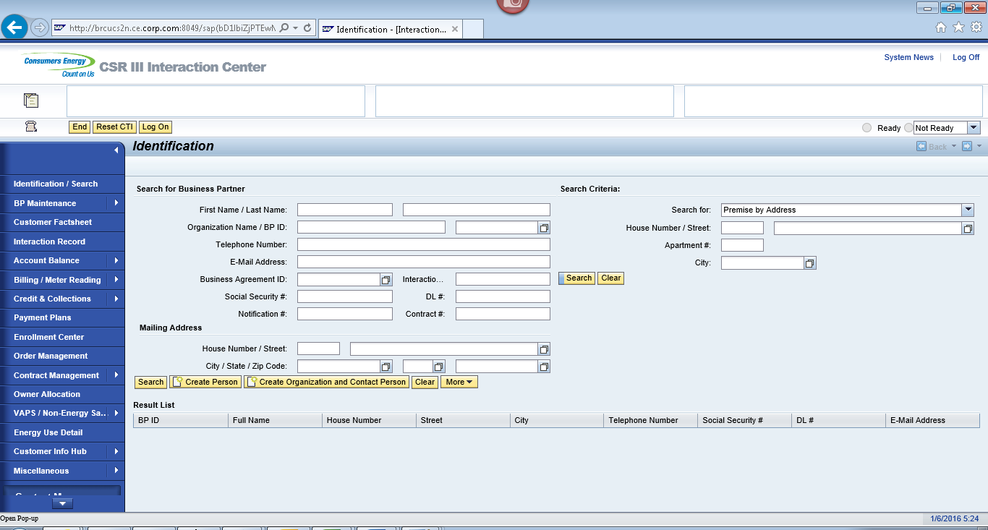
ECC
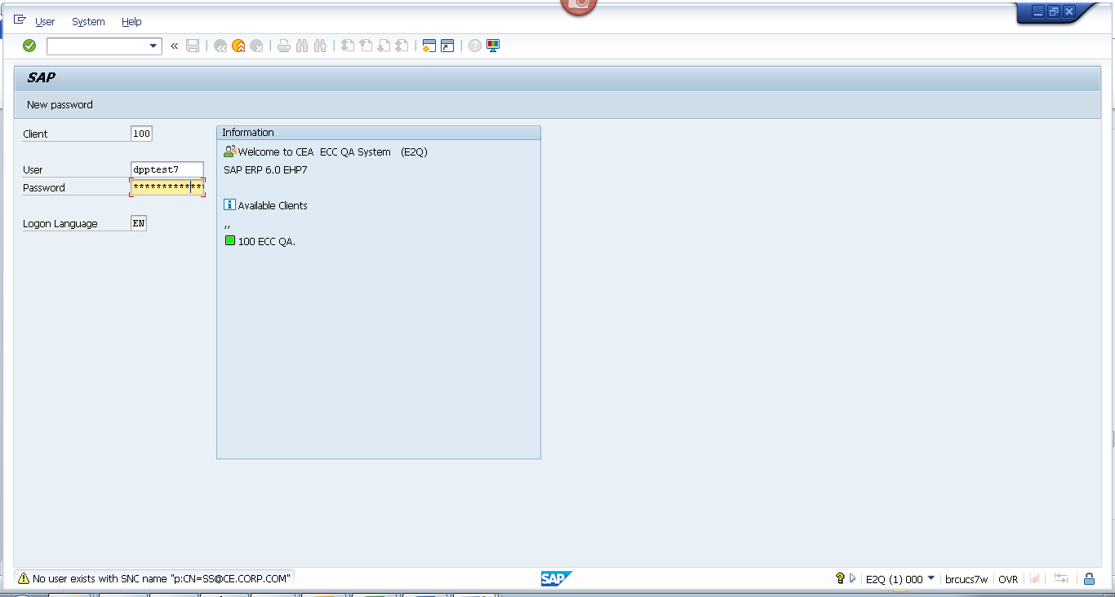
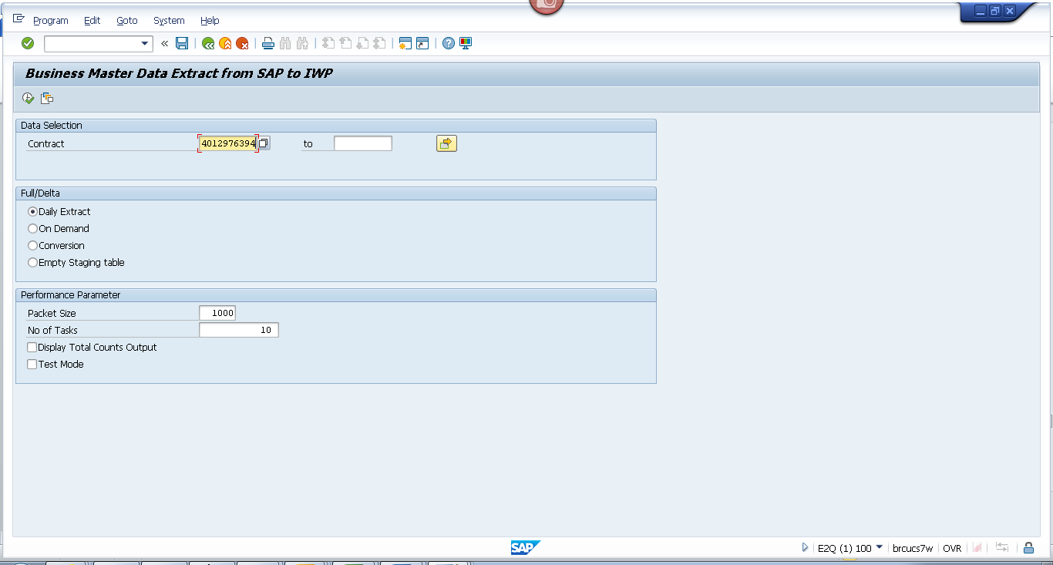
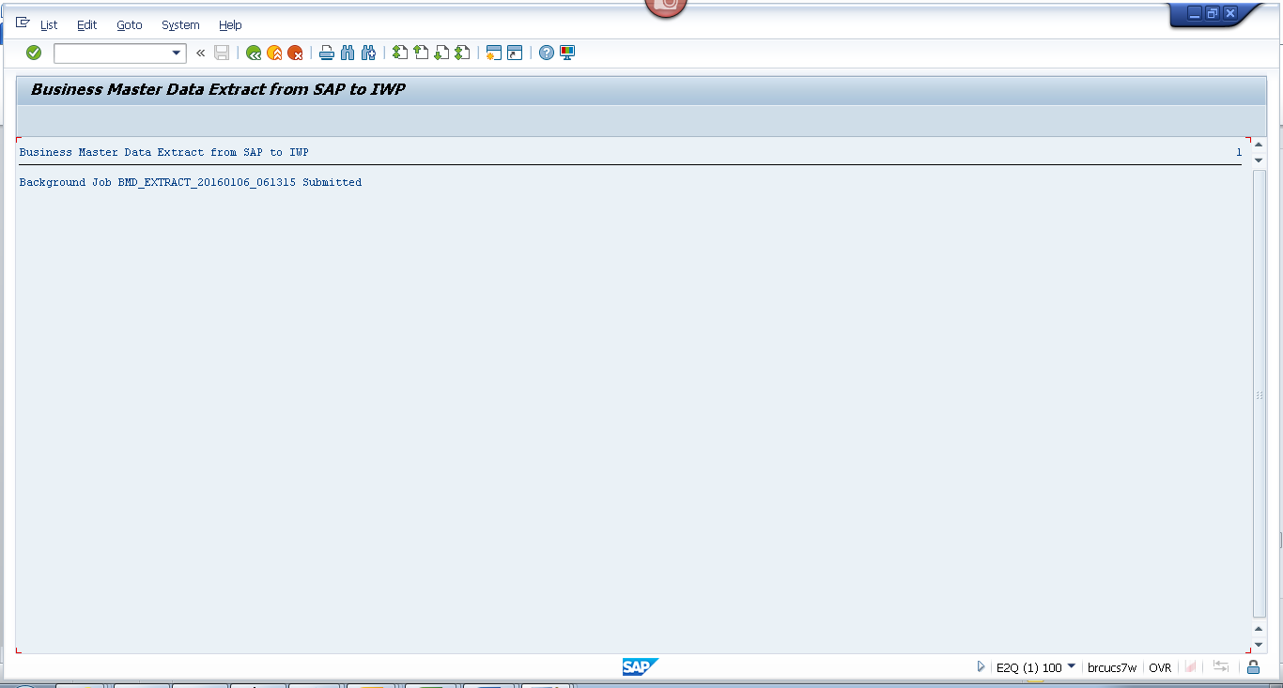

Obj tracking
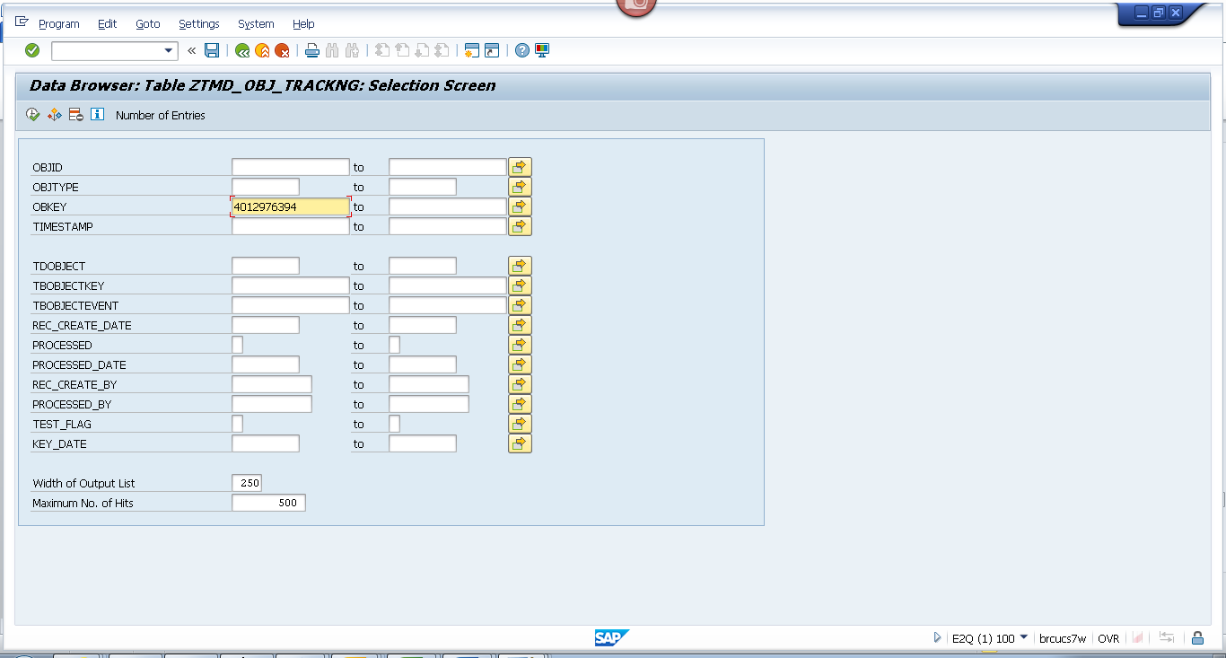
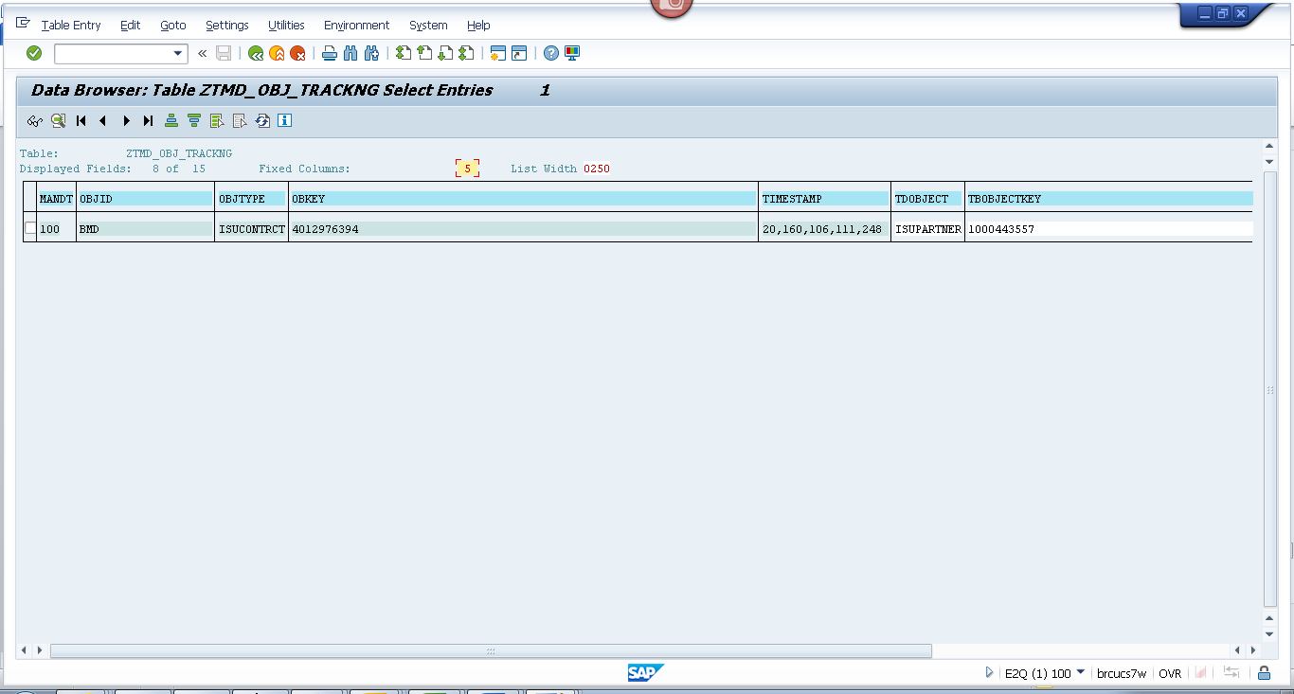
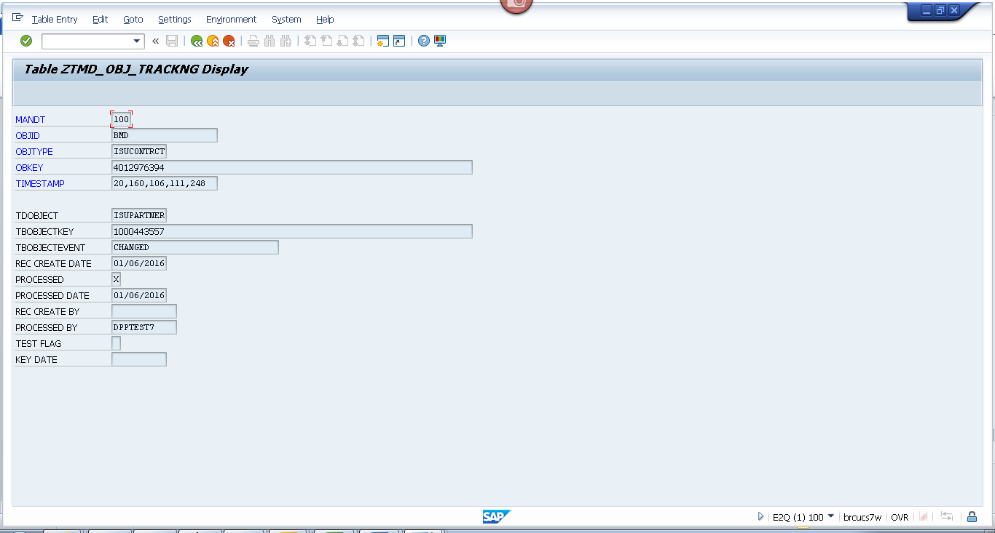

Spool
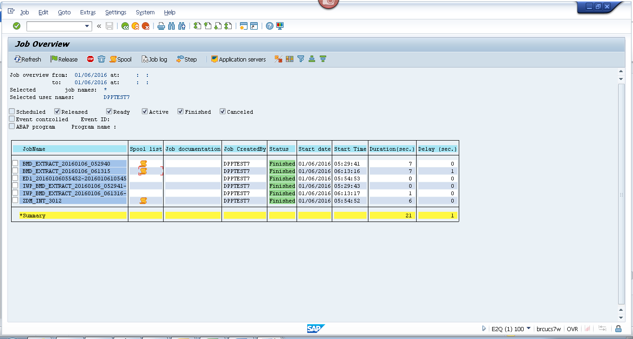
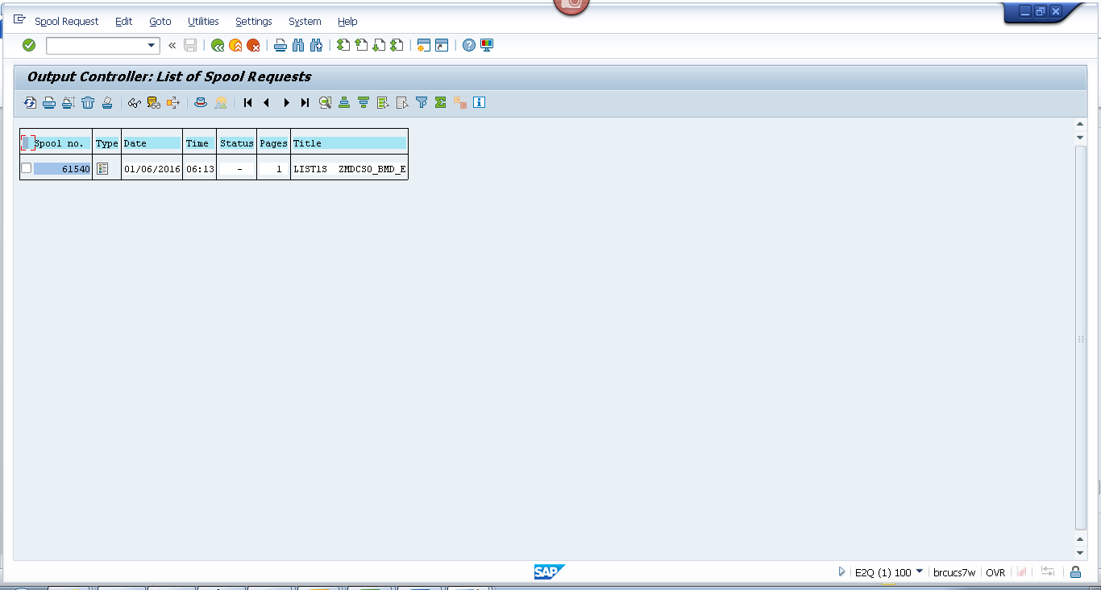
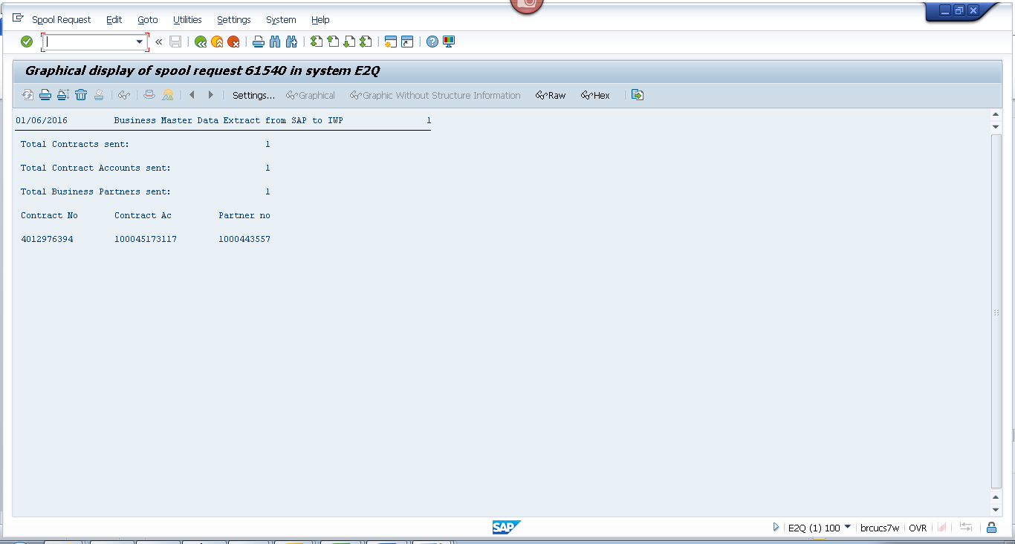

Payload
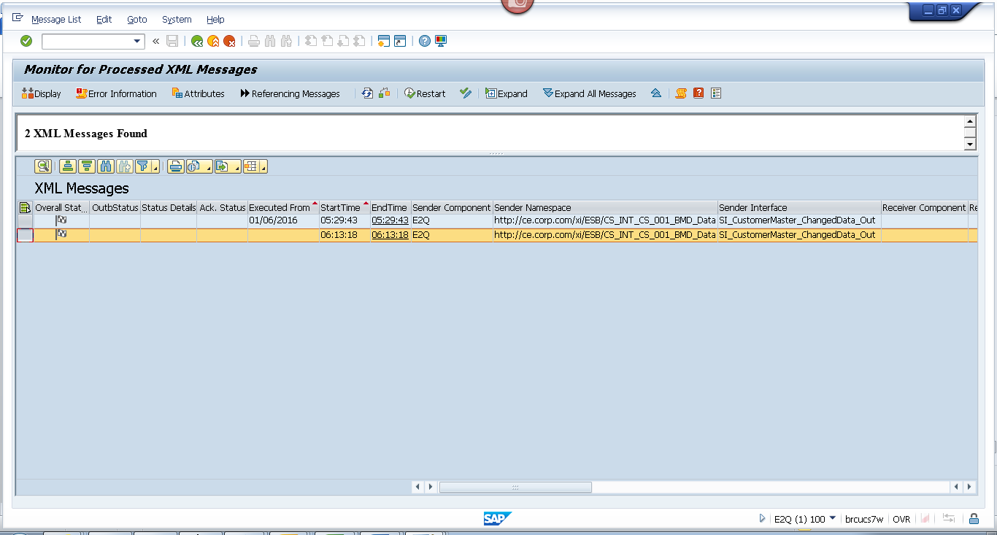
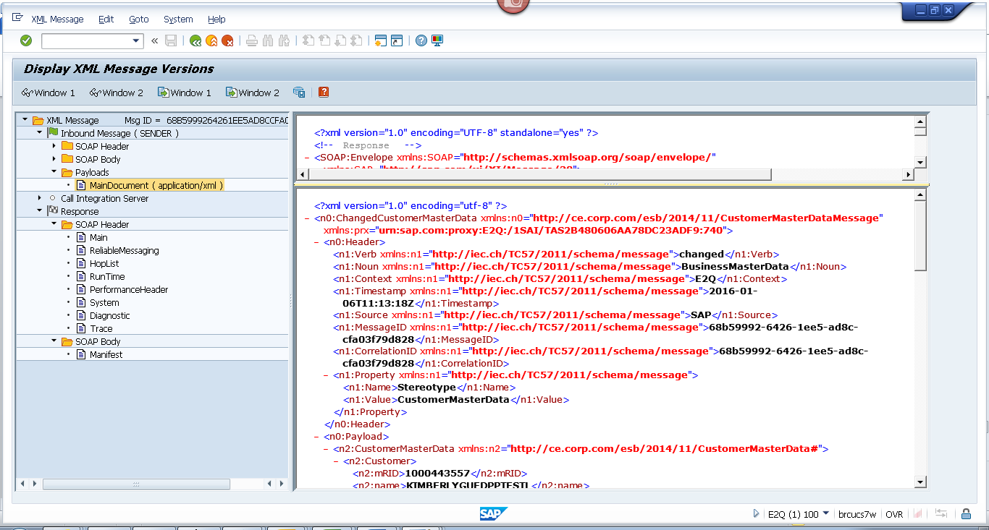
<?xml version="1.0" encoding="utf-8" ?>
- <n0:ChangedCustomerMasterData xmlns:n0="http://ce.corp.com/esb/2014/11/CustomerMasterDataMessage" xmlns:prx="urn:sap.com:proxy:E2Q:/1SAI/TAS2B480606AA78DC23ADF9:740">
- <n0:Header>
<n1:Verb xmlns:n1="http://iec.ch/TC57/2011/schema/message">changed</n1:Verb>
<n1:Noun xmlns:n1="http://iec.ch/TC57/2011/schema/message">BusinessMasterData</n1:Noun>
<n1:Context xmlns:n1="http://iec.ch/TC57/2011/schema/message">E2Q</n1:Context>
<n1:Timestamp xmlns:n1="http://iec.ch/TC57/2011/schema/message">2016-01-06T11:13:18Z</n1:Timestamp>
<n1:Source xmlns:n1="http://iec.ch/TC57/2011/schema/message">SAP</n1:Source>
<n1:MessageID xmlns:n1="http://iec.ch/TC57/2011/schema/message">68b59992-6426-1ee5-ad8c-cfa03f79d828</n1:MessageID>
<n1:CorrelationID xmlns:n1="http://iec.ch/TC57/2011/schema/message">68b59992-6426-1ee5-ad8c-cfa03f79d828</n1:CorrelationID>
- <n1:Property xmlns:n1="http://iec.ch/TC57/2011/schema/message">
<n1:Name>Stereotype</n1:Name>
<n1:Value>CustomerMasterData</n1:Value>
</n1:Property>
</n0:Header>
- <n0:Payload>
- <n2:CustomerMasterData xmlns:n2="http://ce.corp.com/esb/2014/11/CustomerMasterData#">
- <n2:Customer>
<n2:mRID>1000443557</n2:mRID>
<n2:name>KIMBERLYGUEDPPTESTL</n2:name>
- <n2:CustomerAccounts>
<n2:mRID>100045173117</n2:mRID>
<n2:createdDateTime>2009-07-20T04:00:00Z</n2:createdDateTime>
<n2:paperBill>true</n2:paperBill>
<n2:paymentTerm>CE21</n2:paymentTerm>
<n2:type>RES</n2:type>
- <n2:CustomerAgreements>
<n2:mRID>4012976394</n2:mRID>
<n2:accountDeterminationID>RT</n2:accountDeterminationID>
<n2:createdDateTime>2009-07-20T04:00:00Z</n2:createdDateTime>
<n2:division>ELECTRIC</n2:division>
<n2:rateCategory>RS_1000</n2:rateCategory>
<n2:startMonth>00</n2:startMonth>
- <n2:Installation>
<n2:mRID>5001228192</n2:mRID>
</n2:Installation>
- <n2:ServiceLocations>
- <n2:UsagePoints>
<n2:mRID>6001186157</n2:mRID>
</n2:UsagePoints>
</n2:ServiceLocations>
- <n2:validityInterval>
<n2:end>9999-12-31T23:59:59Z</n2:end>
<n2:start>2009-07-24T00:00:00Z</n2:start>
</n2:validityInterval>
</n2:CustomerAgreements>
</n2:CustomerAccounts>
- <n2:Indicators>
<n2:type>SENIOR</n2:type>
</n2:Indicators>
- <n2:Indicators>
<n2:type>DLA EXCLUSION</n2:type>
</n2:Indicators>
- <n2:Indicators>
<n2:type>DPP EXCLUSION</n2:type>
</n2:Indicators>
- <n2:Indicators>
<n2:type>DO NOT MARKET</n2:type>
</n2:Indicators>
- <n2:MainAddress>
- <n2:streetDetail>
<n2:buildingName>0023842234</n2:buildingName>
<n2:name>S Bear Lake Rd</n2:name>
<n2:number>410</n2:number>
</n2:streetDetail>
- <n2:townDetail>
<n2:code>49445-2371</n2:code>
<n2:country>US</n2:country>
<n2:name>Muskegon</n2:name>
<n2:stateOrProvince>MI</n2:stateOrProvince>
</n2:townDetail>
</n2:MainAddress>
- <n2:Persons>
<n2:firstName>KIMBERLY</n2:firstName>
<n2:lastName>GUEDPPTEST</n2:lastName>
<n2:mName>L</n2:mName>
- <n2:electronicAddress>
<n2:email1>DPP@CE.COM</n2:email1>
</n2:electronicAddress>
- <n2:landlinePhone>
<n2:localNumber>231-903-3133-</n2:localNumber>
</n2:landlinePhone>
- <n2:mobilePhone>
<n2:localNumber>521-236-5478</n2:localNumber>
</n2:mobilePhone>
</n2:Persons>
</n2:Customer>
</n2:CustomerMasterData>
</n0:Payload>
</n0:ChangedCustomerMasterData>

